SUBMISSION FORM
Please fill out this form and return it to info@esci-ksp.org. and d32375@tier.org.tw

Pillar
☐ Smart Transport
☐ Smart Building
☒ Smart Grids
☐ Smart Job and Consumers
☐ Low Carbon Model Town

Basic Information
Program name:
Hawaii Clean Energy Initiative

Responsible organization:
Hawaii State Energy Office, Department of Business, Economic Development, and Tourism

Strategy:
Hawaii is the most petroleum dependent state in the United States. As the most geographically isolated population center on earth, this dependence leaves Hawaii vulnerable to supply disruptions resulting in the nation’s highest energy prices.
Hawaii has long recognized that its abundant natural resources offer a great opportunity for energy self-sufficiency in its two primary sectors for energy consumption: electricity generation and transportation. The favorable economics of efficiency measures and renewable energy vis-à-vis carbon-based fuels is attracting investments in Hawaii as a clean energy test bed and positioning the State of Hawaii as a global leader in renewable energy.
A key policy driver for progress on clean energy occurred in 2008 when the U.S. Department of Energy (USDOE) and the State of Hawaii entered into a Memorandum of Understanding (MOU) establishing the Hawaii Clean Energy Initiative (HCEI) with a pledge to establish a long-term partnership to make a fundamental and sustained transformation in the way in which renewable energy efficiency resources are planned and used in the State. In 2014, the USDOE and the State of Hawaii reaffirmed the commitment to build a national model for other states and political jurisdictions to meet the challenges of a future energy ecosystem launching HCEI 2.0.

This includes jointly pursuing innovative policies, technologies, and deployment strategies relating to, without limitation: energy efficiency; renewable energy; alternate fuels; electric transmission and distribution systems; energy storage; alternative fuel vehicles; and other forms of clean transportation.

Measure:
HCEI, under the direction of the Hawaii State Energy Office, is a body of laws and regulations that provide guidance and structure on the key objectives of Hawaii’s clean energy future. HCEI is also the group of stakeholders who support the policy framework and are committed to collaborate on achieving HCEI’s policy objectives. A key policy driver was passage of HB 1464 by the Hawaii Legislature in 2009, establishing separate energy efficiency target and strengthening the renewable portfolio standard by requiring each electric utility company that sells electricity for consumption in the state to establish a renewable portfolio standard (RPS) of 40% by 2030. HB 1464 (2009) required the Hawaii Public Utilities Commission (PUC) to establish energy-efficiency portfolio standards (EEPS) that will maximize cost-effective energy-efficiency programs and technologies. In 2009 the combined 40% RPS and 30% EEPS goals equated to a target of 70 % clean energy by 2030.

Since HCEI’s inception, more than 500 megawatts of generating capacity from wind, solar and biomass have been installed statewide. Rooftop solar PV has been a major contributor to the effort which put Hawaii two years ahead of its interim 2015 RPS target. Additionally Hawaii was also ahead of its EEPS goals of 30%. A report prepared for the PUC concluded that Hawaii has the potential to significantly exceed its 2030 target of 4,300 gigawatt-hours of savings. The study estimated the cumulative energy efficiency potential in 2030 is 6,210 gigawatt-hours, or 144 percent of the current EEPS goals.

With HCEI 2.0 it became clear that the original goals of 40% RPS and EEPS by 2030 were too conservative. In 2015, Hawaii passed HB623 that set a new renewable portfolio standard of 100% renewable energy by 2045 and increased Hawaii’s 2020 RPS target to 30%. By becoming the first state in the nation to adopt a 100% renewable portfolio objective, Hawaii has effectively defined the end state objective for all future investments in Hawaii’s electricity sector. This allows the planning of systemic change, not incremental change, towards a new clean energy future that is structurally different than the present model. While interim objectives drive investment, all of the steps must be taken in support of the long-term goal.

HCEI 2.0 will also be reevaluating the EEPS goals. In December of this year HCEI will be hosting a series of charrettes with policymakers, the PUC and additional stakeholders in the community to disseminate the report provided to the PUC estimating Hawaii’s cumulative energy efficiency potential and reassessing the original EEPS goal.

HCEI 2.0 will refocus on tackling transportation. Previously Hawaii’s efforts under HCEI were focused largely on the electricity sector. Although transportation was targeted in the original Hawaii Clean Energy Initiative, minimal progress has been made in curbing petroleum use in the sector. HCEI 2.0, through the Hawaii State Energy Office, enlisted the International Council on Clean Transportation to provide the technical expertise and policy knowledge needed to establish a renewed commitment on a set of goals and a timeline to reduce petroleum-based fuels for transportation.

In 2015 ICCT wrapped up a series of stakeholder consultations and issued a draft Transportation Energy Analysis Report that includes nearly two dozen tactics to be pursued now as well as enabling actions and further analysis to develop a larger pipeline of petroleum reducing tactics to be pursued in the long term. The next step will feature a reconvening of stakeholders to collaborate on development of a transportation roadmap that will most certainly be a major focus of HCEI for many years to come.

HCEI 2.0 is furthermore helping grow Hawaii’s innovation sector. This new emphasis will stimulate deployment of clean energy infrastructure as a catalyst for economic growth, energy system innovation, and test bed investments. Hawaii's emergence as a clean energy test bed is a vital part of the growing clean energy economic cluster beyond tourism and military spending.

In 2014, Hawaii established a clean energy financing program called Green Energy Market Securitization. The GEMS program employs an innovative financing structure to channel low-cost capital from the bond market to make clean energy more affordable. GEMS has begun accepting applications from nonprofit organizations and consumers, who can borrow from the program to install PV systems that will save them money on their electric bills from Day 1, with no money down. Capitalized with $150 million, GEMS is also being offered to residential utility customers for the installation of solar photovoltaic systems and other technologies that support PV interconnection.

Another innovative program signed into law by Governor Ige will help democratize renewable energy by creating a structure allowing renters, condominium owners and others who have been largely shut out of Hawaii’s clean energy transformation to purchase electricity generated at an off-site renewable energy facility, such as a large-scale solar farm.

Act 100, which establishes a community-based renewable energy program, will be particularly valuable on Oahu where there is a high concentration of high-rise condominiums that don’t have sufficient roof space to support on-site solar panels. The law also is expected to provide relief to homeowners and businesses that are located on highly saturated circuits that can’t accommodate additional PV installations.

The community-based renewable energy program also compliments the state's recently launched Green Energy Market Securitization program. Renters, nonprofit organizations and others who have been turned down for clean energy financing can obtain a loan from the GEMS program which can be used to participate in a community-based renewable project.

The next phase of HCEI will develop a roadmap addressing Hawaii’s challenges for greater renewable penetration and energy efficiency measures and the long-term, comprehensive and systematic energy strategies to fulfill that agenda. HCEI 2.0 will focus on stimulating deployment of clean energy infrastructure as a catalyst for economic growth, energy system innovation, and test bed investments. There will also be a renewed emphasis on engaging a wider group of external stakeholders to continue forward momentum toward meeting Hawaii’s clean energy goals

Performance:

The graph below highlight’s Hawaii’s success to date in adopting renewable energy and energy efficiency. By the end of 2014 renewable energy had grown to comprise more than 21 % of electricity sales at Hawaii’s utilities. We are convinced that if we continue on this trajectory – with a continued firm commitment to a renewable energy transformation -- that a 100 % RPS is achievable.

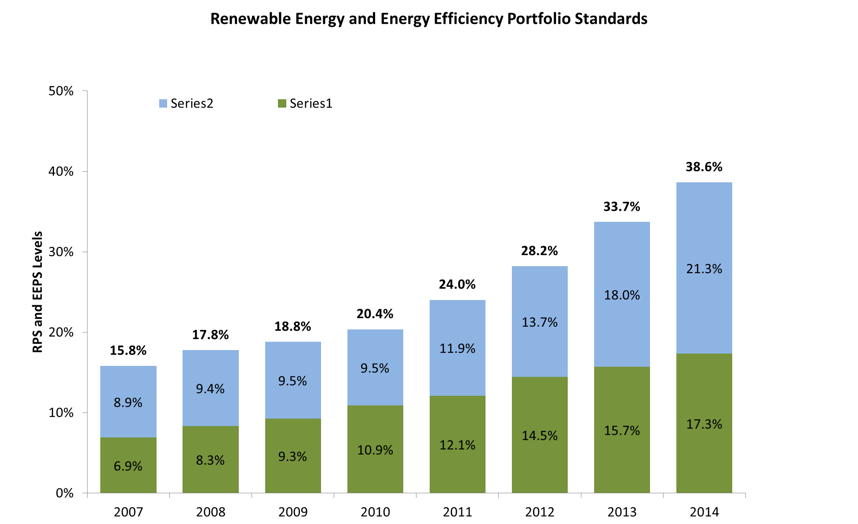

Hawaii is also making exciting headway in the clean transportation sector. Presently, there are over 2,921 EVs on Hawaii’s roads, supported by over 450 publicly available charging stations statewide.

Hawaii is a recognized energy leader, earning recognitions in PV installations and EV penetration.

- 1st Per Capita Top Ten U.S. States Ranked by Grid-Connected PV Cumulative Installed Capacity per Capita (WDC/person through 2013) Interstate Renewable Energy Council’s (IREC) U.S. Solar Market Trends 2013
- Honolulu: First in Nation 2013 The "Solar Stars" (Cities with more than 50 watts of installed solar PV capacity per person, end of 2013) Environment America Research & Policy Center’s “Shining Cities: At the Forefront of America’s Solar Energy Revolution”
- 2013 Installed Solar PV Capacity Clean Edge 2014 U.S. Clean Tech Leadership Index
- 2nd EVs Registered Clean Edge 2014 U.S. Clean Tech Leadership Index
- 5th Honolulu: Top 20 Solar Cities by Cumulative Installed Solar PV Capacity, End of 2013 Environment America Research & Policy Center’s “Shining Cities: At the Forefront of America’s Solar Energy Revolution”
- 6th 2013 PV Installations by State Solar Energy Industries Association’s (SEIA) 2013 U.S. Solar Market Insight Report, Year-In-Review
- 2013 Annual Top Ten U.S. States Ranked by GridConnected PV Capacity Installed in 2013 Interstate Renewable Energy Council’s (IREC) U.S. Solar Market Trends 2013
- 8th Cumulative Top Ten U.S. States Ranked by GridConnected PV Cumulative Installed Capacity though 2013 Interstate Renewable Energy Council’s (IREC) U.S. Solar Market Trends 2013
- 1st Energy Performance Contracting Race to the Top Energy Services Coalition
- 9th LEED Green Building U.S. Green Building Council LEED Green Buildings

.

APEC Economies:

☐ Australia
☐ Brunei
☐ Canada
☐ Chile
☐ China
☐ Chinese Taipei
☐ Hong Kong
☐ Indonesia
☐ Japan
☐ Korea
☐ Malaysia
☐ Mexico
☐ New Zealand
☐ Non-APEC Economy
☐ Papua New Guinea
☐ Peru
☐ Philippines
☐ Russia
☐ Singapore
☐ Thailand
☒ United States
☐ Viet Nam

Additional Project Details
Image:
Please attach an image that represents this project, if one is available, to this email.

Upload:
Please attach a file associated with your project (e.g. pdf, ppt, video or image files) to this email.

Website:
http://www.hawaiicleanenergyinitiative.org/

Contact Information
Contact Name: Kym Sparlin, Program Specialist, Hawaii State Energy Office
Contact Email: Kymberly.M.Sparlin@dbedt.hawaii.gov

