SUBMISSION FORM
Please fill out this form and return it to info@esci-ksp.org. andd32375@tier.org.tw

Pillar
☐Smart Transport
☐Smart Building
☐Smart Grids
☐Smart Job and Consumers
■Low Carbon Model Town

Basic Information
Program name:
Please provide the program title. The title should be brief, unique, and informative.
Low Carbon Actions of Kaohsiung City
Responsible organization:
Please enter the name of the responsible organization.
Environmental Protection Bureau of Kaohsiung City Government

Strategy:
Please refer to the attached criteria to provide further information.
In order to strengthen the capability of climate change mitigation, adaptation and promote the development of a low-carbon city, Kaohsiung city government has established some targets, measures and actions according to different competent authorities and sectors, and kept modified in review and discussion with expertise and executing department, in order to present appropriated and suitable programs for city to develop sustainable and low-carbon life. The following are strategies used and separated into mitigation and adaption:
1.Mitigation
In order to set up decision of establishing Low-Carbon City, Chu Chen, Mayor of Kaohsiung drew up different periods of GHG mitigation objectives in short、middle and long terms, which took 2005 emission as baseline. And revising short term target that 2020 GHG emission will be reduced 20% compared with 2005.
In Kaohsiung City GHG mitigation strategies, the government assessed previous results of related projects and drafted 6 promoted lines(picture 1), including “Green Economy”、“Low-Carbon Corporate”、“Energy saved construction”、“Ecomobility”、“Green Ecology” and “Low-Carbon Education”, which conclude every life section in economy development、industrial and business、city construction、transportation、ecology and education.
In previous 6 promoted lines, carbon reduced works of city include every technical section, which needs every related bureau to promote and establish practical targets in order to complete missions. For achieving final objectives of reducing emission and building Low-Carbon & sustainable city, the government has to consider each bureau’s responsibility and affair, then establish practical actions which are managed and promoted by every bureau.

1.Green Ecology: promoting green business and consumption - Economic Development Bureau
2.Low-Carbon Corporate: consulting industrial and business to energy saved and GHG managed – Environmental Protection Bureau
3.Energy saved construction: promoting green building and solar energy – Public Works Bureau and Economic Development Bureau
4.Ecomobility: promoting public transportation used ratio and building short access city – Transportation Bureau
5.Green Ecology: promoting local food、maintaining ecology and biodiversity、green planting and promoting biomass energy –Agriculture Bureau and Public Works Bureau
6.Low-Carbon Education: environmental protection and Low-Carbon life propagation – Education Bureau and Environmental Protection Bureau
picture 1 the framework of Kaohsiung City GHG mitigation strategies

2.Adaptation
Since each adaptation area has its own level of vulnerability and each area may suffer different degrees of impact from climate change, the evaluation of the influence of climate change and the formulation of adaptation strategies should stress the differences between areas, in order to present the special characteristics of adaptation work so as to set up the scheme according to a certain area's properties.
In order to supervise the implementation, prospects and objectives of each area’s adaptation strategies in a more effective way, a complete planning and objective system has been built. First, through careful discussions between the project teams and working groups, each area should set up its overall objective, and survey each final result to see if the objectives are achieved. While reaching the stage of follow-up strategy planning, each plan has to set up its own working and performance indicator, in order to evaluate and review each plan's implementation results and performance. Here the working indicator includes some specific and representative items that each Ministry and Council should achieve, such as the amount of jobs finished, output value, the square measure, and mileage, etc. As for the performance indicator, which means the level of improvement and benefits resulting from climate change, this has to include items such as reducing the frequency of drastic weather changes, decreasing loss of life and property, cutting down time and expenditure, lowering the level of vulnerability, and enhancing the adaptive capacity, etc(Table1).

Ｔable 1 Number of Action Plans and adaptation strategies
Adaptation Areas | Adaptation Strategies | Action Plans
Disasters | 15 | 99
Infrastructure | 7 | 52
Water Resources | 10 | 59
Land Use | 8 | 52
Coastal Zones | 12 | 45
Energy Supply and Industry | 6 | 46
Agriculture Production/Biodiversity | 10 | 31
Health | 5 | 40

Measure:
Please refer to the attached criteria to provide further information.
There are now many measures and plans undergoing in Kaohsiung City to decrease the impacts caused by extreme weather and climate change, they are focus on factory energy management system, transport sector (light rail transit & intra-city community bicycle), solar heated water supply facilities, roof greening and solar thermal utilization. The following will list 21 related measure to demonstrate present works and plans executed by Kaohsiung City:

- Energy and Resource Integrated Project:
Kaohsiung city government has successfully promoted the Project of Energy and Resources in LinHai industrial park, taking China Steel Company (CSC) as the core selling waste heat and steam to surrounding factories. In 2014, CSC sold 18.9million tons steam, which would be equal to reducing emission 434 thousand tons CO2e produced by burning fossil fuels.
- GHG Emission Reduction and Control Autonomous Regulations:
According to the Kaohsiung’s Environmental Maintenance and Management Autonomy Regulations, the Environmental Protection Administration or central competent authority shall declare public and private spaces for stationary sources of emissions of greenhouse gases, which should set a self-management plan, setting greenhouse gas reduction targets of the process
- GHG inventory and reduction:
Kaohsiung City Environmental Protection Bureau actively promotes energy-efficiency and reduction of greenhouse gas emissions of the project. According to the ISO14064 standard, the plants should be assisted by the task of inventory, reduction of counseling and log in. From 2009 on, Kaohsiung City Environmental Protection Bureau has investigated all of the plant located in Kaohsiung in accordance with the ISO14064-1 and cancelled over 51 plants. Furthermore, Kaohsiung City Environmental Protection Bureau has made a survey to know how many plants located in Kaohsiung is willing to cooperate with the plan of voluntary reduction of carbon reduction. It was estimated that there are reduction amount on Carbon reduction by 71,808 tons in the seven years ,which resulted from 6 times counseling on 2012.
- Energy management counseling, efficiency improvement:
Carbon Reduction Technique Foundation’s counseling founded on 2014 aims to provide both on diagnosis, analysis on the energy usage of general plants’ production or relevant facility and on assistance for factory owners to set up an improvement to realize the practically using situation ,which can be seen as a reference of level-up efficiency and up-graded information.
Take the example on 2014, if cooperated with the project, three plants on the plan were improved their overall carbon reduction benefits, saving energy consumption totaled of 7,080,300 degrees of the total electrify amount and3.569 million cubic meters of natural gas per year, saving energy costs total 2,533 million, representing a decrease of approximately 4,366.3 metric tons of carbon dioxide equivalent emissions per year.
- Promote the Energy Service Company (ESCO):
Kaohsiung City Government largely introduced energy saving companies (ESCOs) to the city. It can not only integrate power from private companies to update energy-saving equipments, but also stimulate the development of green economy in Kaohsiung.
- Green Building Autonomous Regulations
In order to promote green building for fulfilling the vision of low-carbon city, Kaohsiung city government imposed Green Building autonomous regulations in Jun., 2012. It forces that new building construction and old building renewal, with different scales; need to fulfil certain levels of green building standards.
- Green Roof and community:
The KCG has been promoting green roof and space in the city. Up to 2014, green space reached 467 places, 152 ha in public place. 6962 GHG reduction is anticipated.
- Subsidy for solar photovoltaic installations:
Subsidy for solar photovoltaic installations. The solar photovoltaic is subsidized NT$10,000 (US$333) per KWP, and each subsidy is limited NT$300,000(US$10,035),and each applicants is limited NT500,000(US$16,667) for more than one subsidy.
- Green Financing:
Kaohsiung city government imposed "Green Financing - Commercial loans and strategic loan (III, IV)”, providing NT$200 million low-interest loans to photovoltaic system operators in 2012, and adding NT$100 million loans for Kaohsiung citizens willing to set up solar photovoltaic systems.
- Subsidy to old buildings renovation:
Kaohsiung city government provides subsidy to private buildings to improve its energy efficiency. The subsidy covers LED lights, water-saving taps…etc and is up to NT$20000 (USD$ 666).
- Extending Cycle Way:
Kaohsiung city government continuously extends cycle way to create a cycle-friendly environment to bikers. Cycle way of over 755 km long has been built.
- Set up more public bike rental system:
Kaohsiung continuously set up new public bike rental stations. So far, 159 stations have been set up, which can provide 200 ,000 citizens to use each month.
- Public transportation transferring privilege and shuttle buses:
Adding shuttle buses for KMRT (Kaohsiung Metro Rapid Transit) users, and providing privilege for people transferring between KMRT and public buses, aiming to double public transportation users.
- Kaohsiung Light Rail:
Kaohsiung is building a light rail system. The project with 22.1 km long, includes two stages. So far, the first stage is underway, and will be completed and operated in Jun., 2015, while the whole stage would be operated in 2019.
- Subsidy to green transport (electronic scooters):
The city government provides subsidies to replace two-stroke scooters with electronic scooters. The subsidy is NT 23,000 (USD$ 766) at most. Up to 2014, more than 6,000 electronic scooters has been subsided.
- Wetland Conservation:
Kaohsiung city government put lots of efforts in the issue of wetland conservation because of its abilities of carbon fixing, unban flood detention, and ecological and recreational value. The city has successfully created 19 wetland parks in Kaohsiung with total area about 1,125 hectare.
- Advocating Green Campus:
Many actions have been taken between 2005 and 2009 to advocate green campus, and the impressive results are in 6 aspects including illumination, energy conservation, planting, water conservation, recycling and thermal insulation.
- Encouraging Green Purchase:
In order to stimulate the development of green economy in Kaohsiung, the city government promotes goods with green labels, including energy-saving label and water-saving label, to citizens.
- Buildings: Kaohsiung Main Public Library:
The green energy environmental concept of the building: Kaohsiung Main Public Library is integrated into every floor; the design of the third to eighth floors on the southwest side is a five-meter-deep green turf landscape balcony providing a cool place to hide from the burning rays of Kaohsiung’s summer, and also allowing citizens to lie on a lawn, or read under a tree, thus providing an excellent green space for reading.
- Community-Scale Development: The project of Low-carbon and Sustainable Homes
Kaohsiung City Government coordinates with nation’s low-carbon strategy so as to promote and operate the plan of local low-carbon and sustainable homes, such as “The ten operational functions” and so forth.
- Kaohsiung house designing and feedback project:
In response to the impact of climate change and the advent of an aging society, Kaohsiung city government imposed Kaohsiung house designing and feedback project in September,2014. The estimation base is 20% of 5829 buildings constructed in 2013: The setting of three-dimensional green roof increases the total green area of 11 football fields, and total power generation is about 18 National Stadiums. All green building practices creates 16,619 tons carbon reduction, equivalent to about 1.66 million trees planted in carbon sequestration.

Performance:
Please refer to the attached criteria to provide further information.
The following is the table to demonstrate and present the mitigation amount by each bureau of Kaohsiung City Government according to different GHG mitigation strategies it used,

Table 2 bureau mitigation amount of Kaohsiung City GHG mitigation strategies
Item | Participating Government  Department | Green Economy | Low-Carbon Corporate | Energy saved construction | EcoMobility | Green  Ecology | Low-Carbon Education | Total
1 | Environmental Protection Bureau | 301.00 | 199.72 | 0.96 | 1.73 | 0.86 | 8.72 | 512.98
2 | Economic Development Bureau | 11.08 | 300.35 | 8.26 |  |  |  | 319.69
3 | Education Bureau |  |  | 0.00 |  | 0.06 | 5.45 | 5.52
4 | Labor Affairs Bureau |  |  | 8.43 | 2.07 | 1.16 |  | 11.66
5 | Kaohsiung Mass Rapid Transit |  |  |  | 6.80 |  |  | 6.80
6 | Agriculture Bureau |  |  |  |  | 3.46 |  | 3.46
7 | Transportation Bureau |  |  |  | 6.12 |  |  | 6.12
8 | Secretariat |  |  |  |  |  | 1.73 | 1.73
9 | Finance Bureau |  |  |  | 0.02 |  |  | 0.02
10 | Tourism Bureau |  |  |  |  |  | 0.00 | 0.00
11 | Urban Development Bureau |  |  |  |  | 0.04 |  | 0.04
Total |  | 312.08 | 500.07 | 17.66 | 16.73 | 5.58 | 15.90 | 868.02

APEC Economies:

☐ Australia
☐ Brunei
☐ Canada
☐ Chile
☐ China
■ Chinese Taipei
☐ Hong Kong
☐ Indonesia
☐ Japan
☐ Korea
☐ Malaysia
☐ Mexico
☐ New Zealand
☐ Non-APEC Economy
☐ Papua New Guinea
☐ Peru
☐ Philippines
☐ Russia
☐ Singapore
☐ Thailand
☐ United States
☐ Viet Nam

Additional Project Details
Image:
Please attach an image that represents this project, if one is available, to this email.
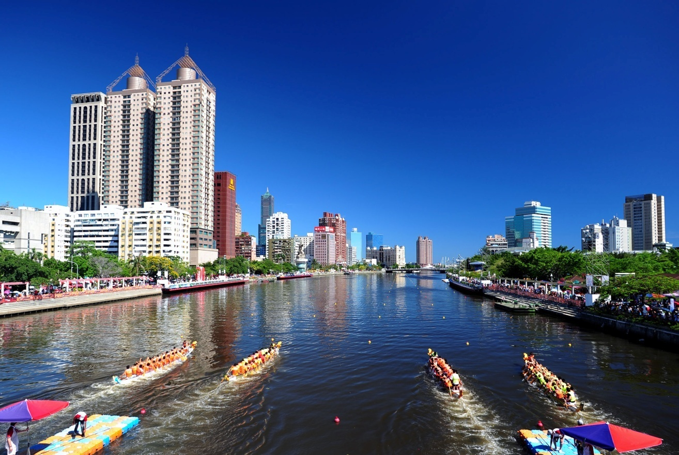
Upload:
Please attach a file associated with your project (e.g. pdf, ppt, video or image files) to this email.
Low Carbon Actions of Kaohsiung City (ppt)
Website:
Enter a project website.
N/A
Contact Information
Contact Name: Please enter your name so ESCI users can contact you with questions.
Environmental Protection Bureau of Kaohsiung City Government
Contact Email: Please enter your email address so ESCI users can contact you with questions.
audi8238@kcg.gov.tw

